WELCOME TO THE HONOR GUARD!

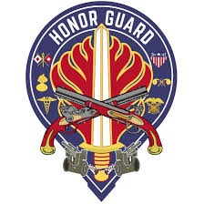Congratulations on your assignment joining us at the 529th Military Police Company “Honor Guard”. You have joined the premier Honor Guard unit for the United States Army Europe and Africa Command. The 529th is a unique Military Police Company, with personnel stationed in both Wiesbaden, Germany and Vicena or Livorno, Italy. Additionally, we are charged with not only Military Police duties, but also Professional Ceremonial support! For a bit of history, in December of 1946, the 529th Military Police Company received its nomenclature while assigned to the European Command. In 1952, our company was officially designated as the Honor Guard for U.S. Army Europe, a prestigious title that continues to this day as we serve as the USAREUR-AF Honor Guard unit based out of Wiesbaden, Germany.

Prior to your arrival, a sponsor will be assigned to you to assist with your transition over to Europe. We ask that once you receive an email, please ensure to fill out all required sections on the Army Career Tracker (ACT) website, especially with a point of contact. Whether text, call, email, or one of the several apps available today, we can be flexible to make sure regular communication occurs as your date of arrival nears.

With the PCS being OCONUS, the following topics may apply, and you should communicate to your sponsor if any might cause difficulties with your reception:

1. Command Sponsorship: Ensure dependents are eligible for a fully funded overseas assignment. They must be on your orders. See: [MPD | USAG Wiesbaden](https://home.army.mil/wiesbaden/about/Garrison/directorate-human-resources) / [MPD | USAG Italy](https://home.army.mil/italy/about/Garrison/directorate-human-resources/military-personnel-division)
2. Special Programs: Exceptional Family Member Program (EFMP): screening with EFMP is necessary for anyone set to PCS with a family, Married Army Couples Program (MACP) details for dual military couples, and Buddy-Program enrollment can impact your assignment. Start working those details, the earlier the better, as the whole process can take 3-5 months. See [EFMP | USAG Wiesbaden](https://installations.militaryonesource.mil/military-installation/usag-wiesbaden/exceptional-family-member-program/exceptional-family-member-program) / [EFMP | USAG Italy](https://installations.militaryonesource.mil/military-installation/usag-italy/exceptional-family-member-program/exceptional-family-member-program).
3. Passports / Visas: Prior to the PCS, learn which travel documents are required before being stationed overseas. See: [USAG Wiesbaden Passport Office](https://home.army.mil/wiesbaden/about/Garrison/directorate-human-resources/passportvisa) / [USAG Italy Passport Office](https://home.army.mil/italy/my-garrison-Italy/pcsguidevic/pre-arrival-vicenza/passports-visas).
4. Lodging: Please communicate your family's composition, to include pets, to ensure your sponsor reserves the appropriate lodging!
5. Mailbox: Prior to arrival, your sponsor can establish your P.O. Box. Only requires a copy of your orders!
6. Child and Youth Services (CYS) / School Registration. Sign up for [Military Child Care](https://militarychildcare.csd.disa.mil/mccf/ui/#/) online for your gaining location to be ready to support your childcare needs. Enroll your children in [DoDEA schools](https://www.dodea.edu/registration-process.cfm) as soon as possible and contact your School Liaison Officer (SLO) for assistance.

We are excited to have you join our unit. You are transitioning into a unit with a rich history and fulfilling mission set. Remain in contact with your sponsor, and feel free to ask questions, they are there to help you! Welcome to the Honor Guard Family.

“FOR THE CANNONS!”

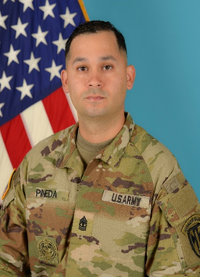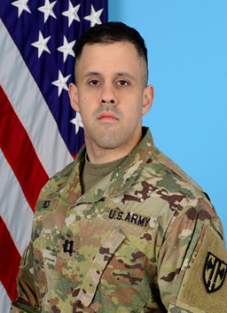

DERECK PINEDA

1SG, USA

First Sergeant

ALLAN N. RICO

CPT, MP

Commanding